Assignment Brief
Assignment title: Website Design Project
Assignment brief

You have applied for a job with DevelopCornwall - a local website development company - and as part of the selection process, they have tasked you with researching, designing, developing, and documenting a small web development project.

Mr Sandle has given you 2 projects to choose from and emphasised that the final website should be modern, user-friendly, fully functional, and align with the project's requirements.

Project 1 - Digital Portfolio
A digital portfolio is essential for presenting accomplishments, projects and skills in a visually appealing and organised manner. DevelopCornwall want to see a digital portfolio that reflects your skills, capabilities, and passion for the digital sector - including any recent projects/work that you have completed and highlighting any expertise.
You could include:
- Index Page
- Portfolio Section
- About Me
- Skills & Experiences
- Contact Page

Project 2 – Informative Website on a topic of your choosing
Design and develop a website that explores a topic of interest. For example, the website could highlight a selection of famous landmarks, animals, historical events, or even world cuisines. The site should educate visitors about various subjects in an organised and engaging way. You could include:
- Index Page
- Topic page(s)
- About Me
- Contact / Feedback page

As a minimum, you will be required to submit the following:
Documentation:
- Analyse current trends, technologies & techniques, and the benefits of having a web presence, justifying the most appropriate web host.
- Summarise how to save the website with appropriate file names and how you have structured your web pages to improve search engine ranking (SEO)
- Summarise a range of planning methods and create suitable design documentation for your website.
Website:
- Develop a website (minimum of 3 pages), based on your design documentation.

For this assignment you will be graded in the following way:

There are no descriptor statements for a ‘Pass’. Students achieve a Pass by meeting the requirements of all the assessment criteria of a unit.

If work is submitted after the formal deadline has passed, and no extension has been granted, all grade indicators relating to the unit are capped at a Pass.

Grading Standard 1: Knowledge and Understanding
Merit  The student’s work: | Distinction  The student’s work:
Generally, demonstrates the ability to apply knowledge appropriately in a given context showing breadth of knowledge in responding to the demands of the unit,  With  A very good understanding and use of:  - facts  - concepts  - procedures | Consistently demonstrates the ability to apply knowledge appropriately in a given context showing breadth of knowledge in responding to the demands of the unit,  With  An excellent understanding and use of:  - facts  - concepts  - procedures

Grading Standard 2: Subject Specific Skills
Merit  The student’s work : | Distinction  The student’s work:
Generally, demonstrates an ability in selecting and using skills as required by the unit,  With  A very good level of:  - accuracy  - reasoning  - interpretation | Consistently demonstrates an ability in selecting and using skills as required by the unit,  With  An excellent level of:  - accuracy  - reasoning  - interpretation

Grading Standard 3: Transferable Skills
Merit  The student’s work: | Distinction  The student’s work:
Demonstrates very good communication skills evidenced by the use and selection of:  • format  • structure  • grammar  • spelling and punctuation  b. demonstrates autonomy and independence evidenced by a very good ability to:  • plan, organise and complete work  • conduct independent research  • manage time  c. generally adheres to professional conventions in use of technical language in responding to the instructions set out in the assignment brief. | Demonstrates excellent communication skills evidenced by the use and selection of:  • format  • structure  • grammar  • spelling and punctuation  b. demonstrates autonomy and independence evidenced by an excellent ability to:  • plan, organise and complete work  • conduct independent research  • manage time  c. consistently adheres to professional conventions in use of technical language in responding to the instructions set out in the assignment brief.

Assignment Feedback Sheet

Access to HE Diploma (subject title)

Student name |  | Submission deadline date | 21/03/2025
Course/  subject title | Access to HE: Computing | Submission date
Unit title/code | Website Design Project 3914 | Extension granted
Assignment status* | 1 of 1
Tutor name | Kendle Lewis | Re-submission deadline date
Date set | 27/01/2025 | Re-submission date
Internal moderation | YES  Signature   | Referral requested  Specify if the referral is following a late submission (and therefore to be capped) | YES / NO

This is all my own work and all sources have been acknowledged and attributed.

Student signature (hard copy submission only)

Learning outcome | Assessment  criteria | FS | RS | Achieved
1. Plan a website using an identified brief | 1.1 Summarised a range of planning methods e.g. Visualisation, Storyboard, conceptualisation.
1.2 Analysed current trends, technologies &
techniques and the market value and
benefits of a web presence.
1.3 Provided a layout of the proposed
website design and a hierarchical structure of the site.
2. Use hypertext mark-up commands to achieve a desired page layout. | 2.1 Performed hypertext mark up  commands to create a page including:  a) headings  b) subheadings  c) body text
2.2 Use appropriate software to:
a) set font and background colours
b) insert and size an image file at an
appropriate place.

3. Use Hypertext to create a small website for an agreed purpose. | 3.1. Written a website of at least three pages  for an agreed purpose. that are hierarchically hyperlinked together incorporating at least:  a) one image file  b) two external hyperlinks  c) one email link.
3.2. Critically compared relative and absolute
addressing.
4. Use hypertext to create a search engine friendly structure. | 4.1. Utilised hypertext to add:  a) a title to each page  b) alternate text to each image used  c) meta data for search engines  (keywords & description).
4.2. Utilised text emphasis on keywords
(heading tags, bold etc.).
4.3. Summarised how to:
a) save the website with appropriate file
names
b) structure web page narrative to improve
search engine ranking.

Tutor Feedback

General feedback

Signed: Date:

Grading feedback
to be completed if the assignment covers all assessment for the unit, or is the last in the series of assessments for the unit.
Grading Standards | Tutor comments | Performance against the Grading Standard  (P/M/D)
GS 1 |  | Eg Merit
GS 2 |  | Eg Pass
GS 3 |  | Eg Merit
Unit grade
Eg: Merit

Nini Ken-Ajayi (Student)
Truro and Penwith College (Desktop 20240725)
Website design project

Introduction
In this assignment I will be presenting my accomplishments, projects and skills in a visually appealing and organised manner using various skills and techniques when creating my portfolio.

Contents
Assignment Brief 0
Introduction 7
1.Plan a website using an identified brief 8
1.1 Summarised a range of planning methods e.g. Visualisation, Storyboard, conceptualisation. 8
1.2 Analysed current trends, technologies & techniques and the market value and benefits of a web presence. 9
1.3 Provided a layout of the proposed website design and a hierarchical structure of the site. 10
2. Use hypertext mark-up commands to achieve a desired page layout. 11
2.1 Performed hypertext mark up commands to create a page including: headings, subheadings and body text 11
2.2 Use appropriate software to: set font and background colour and insert and size an image file at an appropriate place. 12
3. Use Hypertext to create a small website for an agreed purpose. 13
3.1. Written a website of at least three pages for an agreed purpose. that are hierarchically hyperlinked together incorporating at least: one image file, two external hyperlinks, one email link. 13
3.2. Critically compared relative and absolute addressing. 14
4. Use hypertext to create a search engine friendly structure. 15
4.1. Utilised hypertext to add: a title to each page, alternate text to each image used, meta data for search engines (keywords & description). 15
4.2. Utilised text emphasis on keywords (heading tags, bold etc.). 16
4.3. Summarised how to: save the website with appropriate file names, structure web page narrative to improves search engine ranking. 17

1.Plan a website using an identified brief

1.1 Summarised a range of planning methods e.g. Visualisation, Storyboard, conceptualisation.

1.2 Analysed current trends, technologies & techniques and the market value and benefits of a web presence.

1.3 Provided a layout of the proposed website design and a hierarchical structure of the site.

Wire frame
Index page
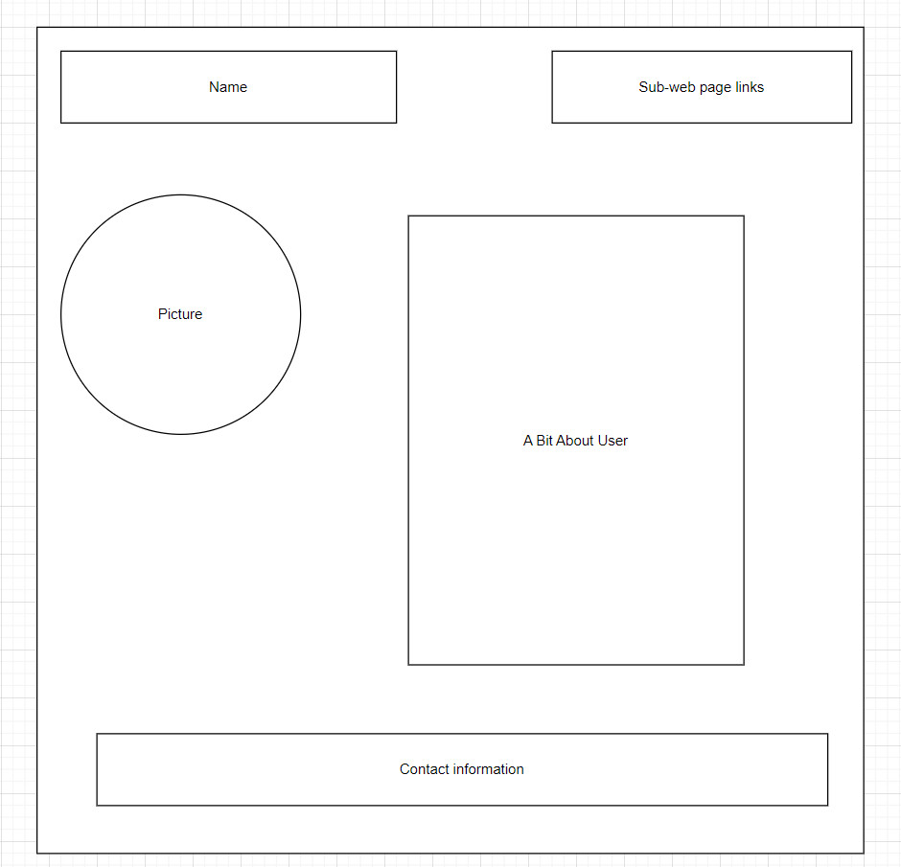

Portfolio page
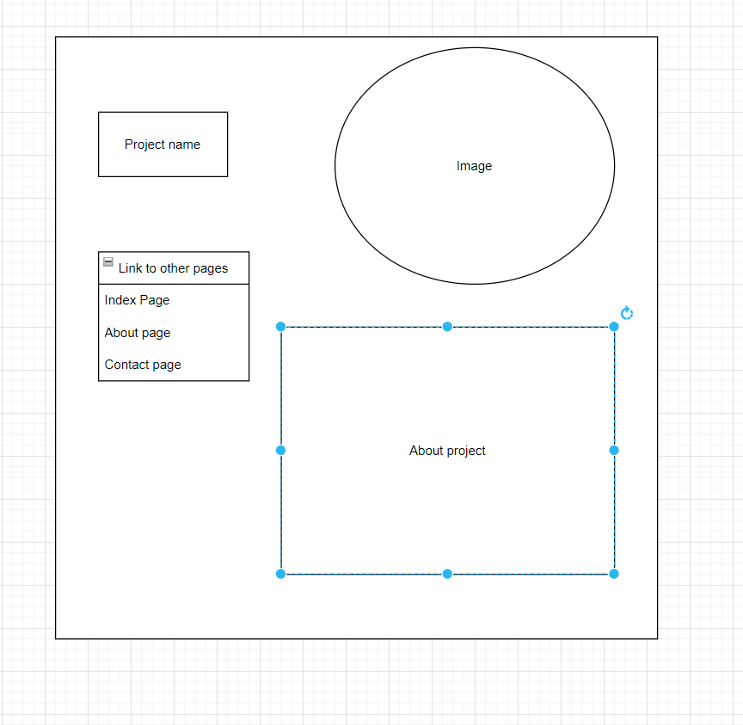

About me page
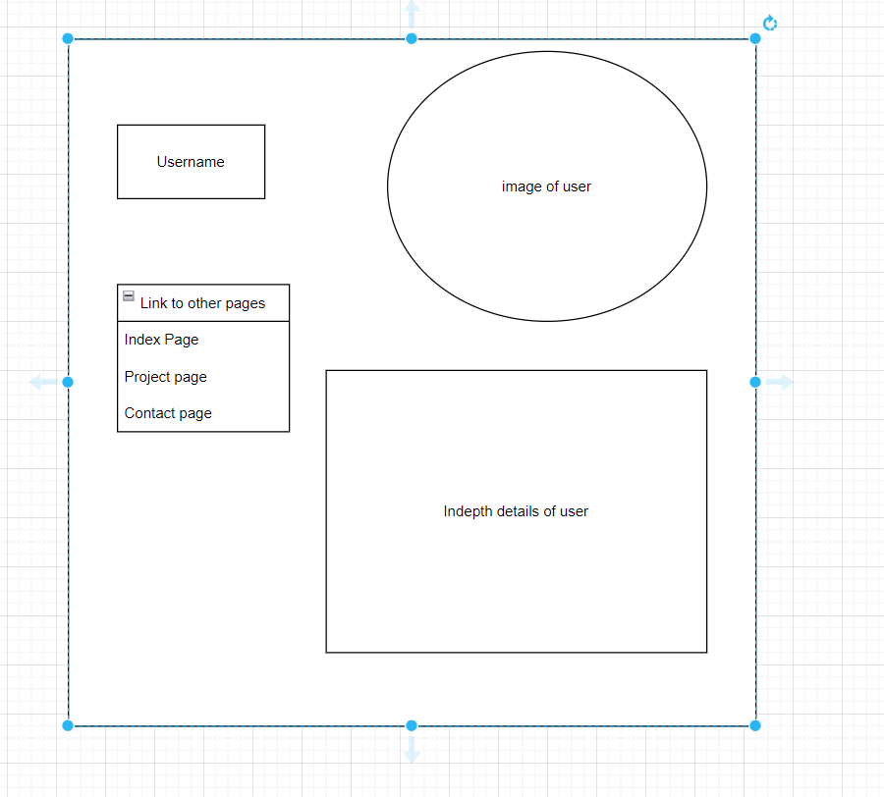

Skills and experiences
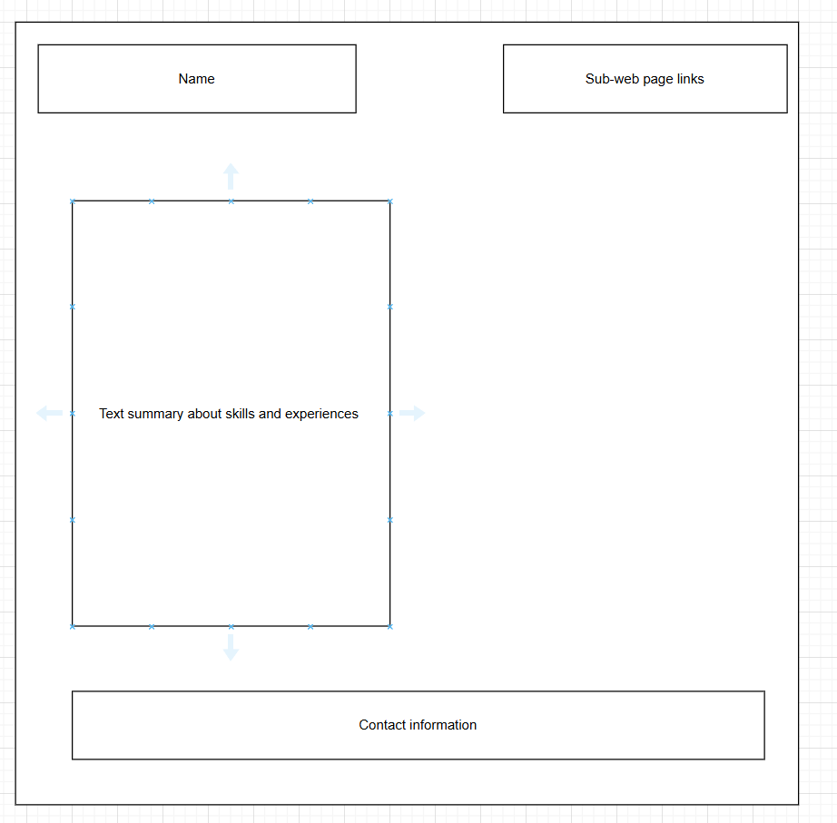

Contact page
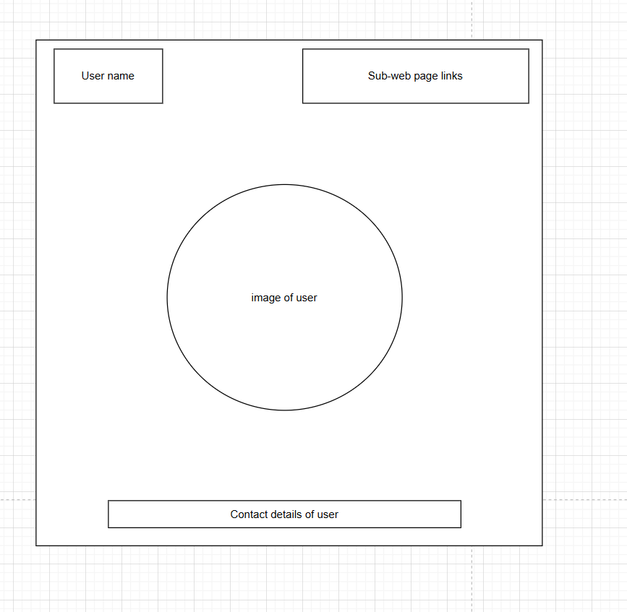

2. Use hypertext mark-up commands to achieve a desired page layout.

2.1 Performed hypertext mark up commands to create a page including: headings, subheadings and body text

2.2 Use appropriate software to: set font and background colour and insert and size an image file at an appropriate place.

3. Use Hypertext to create a small website for an agreed purpose.

3.1. Written a website of at least three pages for an agreed purpose. that are hierarchically hyperlinked together incorporating at least: one image file, two external hyperlinks, one email link.

3.2. Critically compared relative and absolute addressing.

4. Use hypertext to create a search engine friendly structure.

4.1. Utilised hypertext to add: a title to each page, alternate text to each image used, meta data for search engines (keywords & description).

4.2. Utilised text emphasis on keywords (heading tags, bold etc.).

4.3. Summarised how to: save the website with appropriate file names, structure web page narrative to improves search engine ranking.

If yes, attach referral paperwork

